Mini Project # 4

Name of group members: VEDANT KUMAR, JUBEYER RAHMAN

ID: vxk180003, jubeyer.rahman

Contribution of each group member: Vedant (Q1,Q2) Jubeyer (Q3 and cross check Q1, Q2)

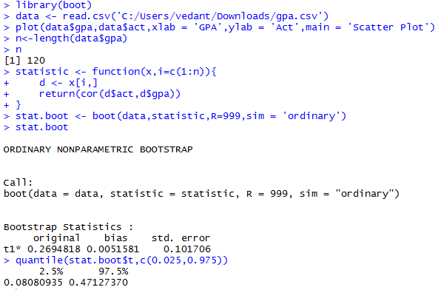

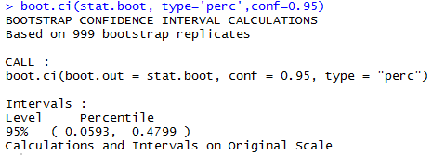

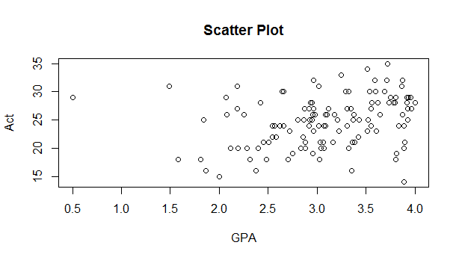

Based on the scatter plot, the relation between GPA and Act seems to be a weak non-linear relationship. The point estimate of the population correlation is 0.2694818, bias to be 0.0051581, SE to be 0.101706 and bootstrap estimate = 0.2694818+0.0051581 = 0.2746399.

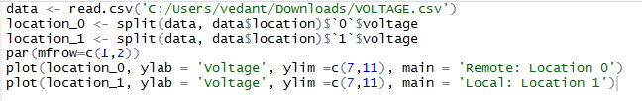

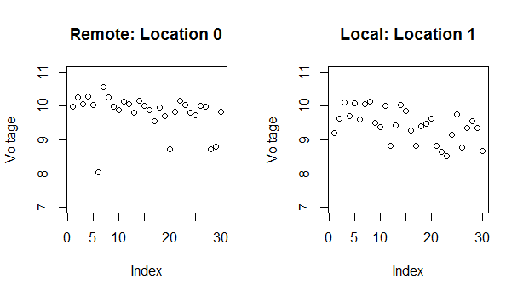

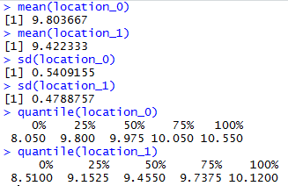

From the scatter plot, it can be deduced that the remote location has readings mostly between 9.5 and 10.5 which can be assumed as the correct value of the voltage required for manufacturing process. The 4 outliers from Remote location can be due to measurement error or can be treated as faulty data which highly impacts the mean value and SD.

The local location on the other side has a lot of readings between 8.5 and 10. In comparison with Remote location, the SD of the data is almost same that concludes the argument that the manufacturing process can be established locally.

The confidence interval for the difference of means with equal and unknown standard deviation is as follows assuming normal distribution with equal population variances.

